TC-CSC-015
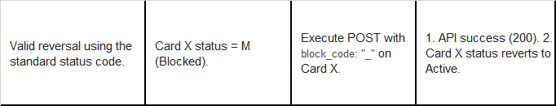
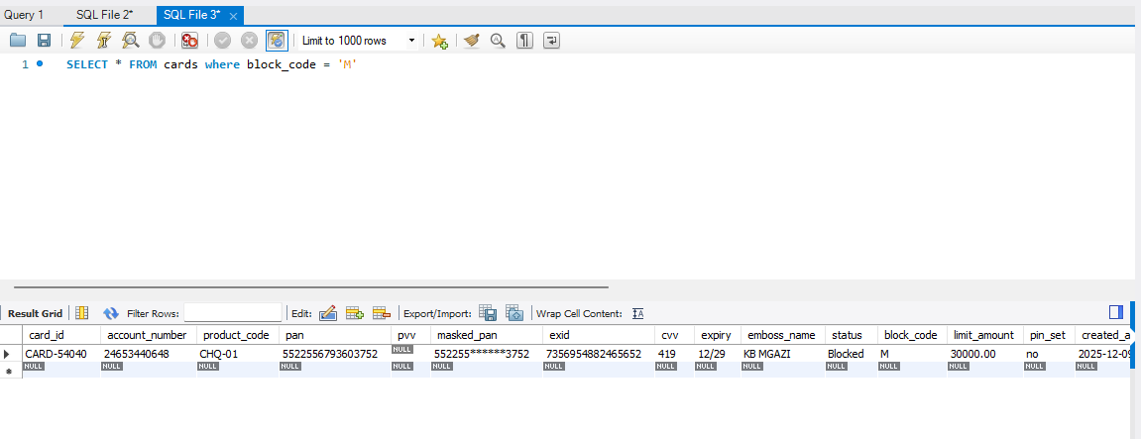
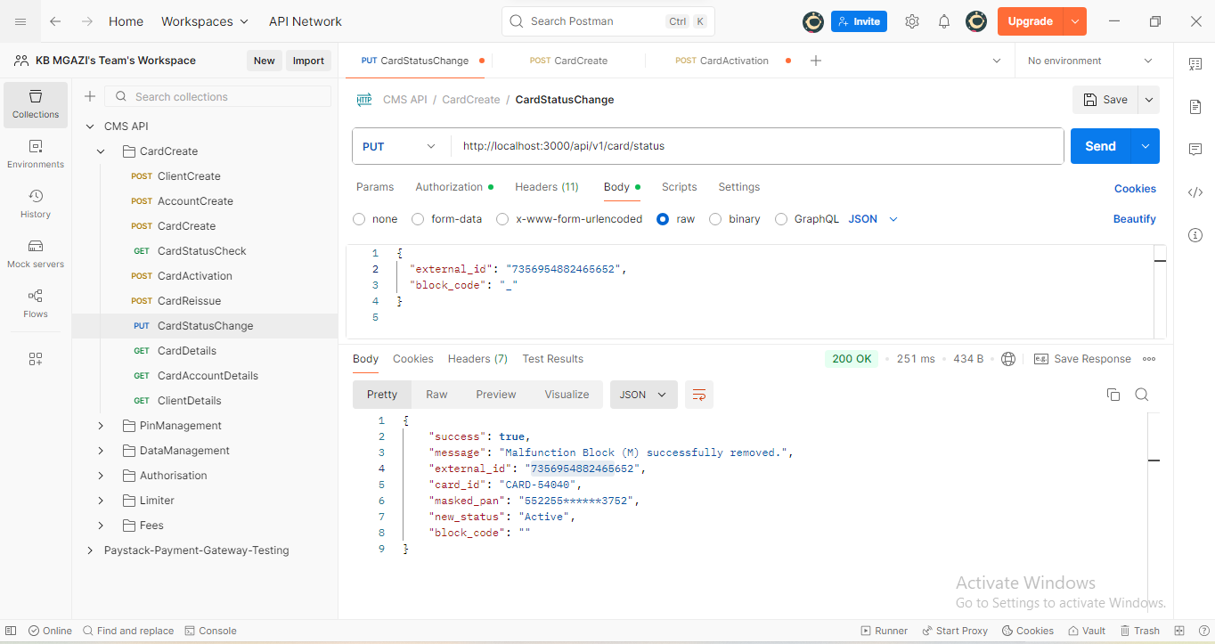
Request:
{
"external_id": "7356954882465652",
"block_code": "_"
}

Response:
{
"success": true,
"message": "Malfunction Block (M) successfully removed.",
"external_id": "7356954882465652",
"card_id": "CARD-54040",
"masked_pan": "552255******3752",
"new_status": "Active",
"block_code": ""
}

